Week5 NLP <3
- Text preprocessing and classical representations
understand how computers process human language
Why do we need text preprocessing?
a machine learning algorithm cannot directly understand the meaning of this sentence. It needs numerical inputs.
Therefore, we need to:
- Clean and prepare the text.
- Split the text into smaller units.
- Convert the text into numerical representations.
- Feed those numerical representations into a machine learning model.
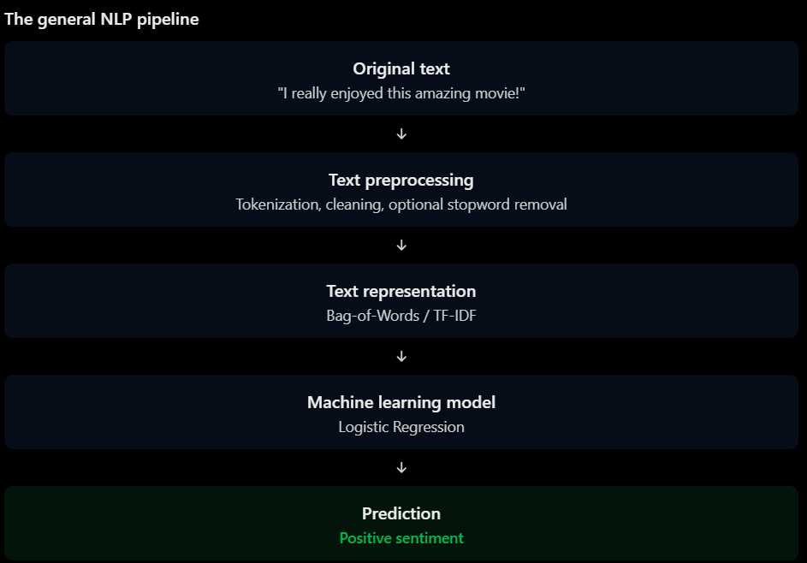
- Text Preprocessing and Classical Representations
1.1 Tokenization
Tokenization is the process of splitting text into smaller units called tokens.
A token can be: word, character or subword
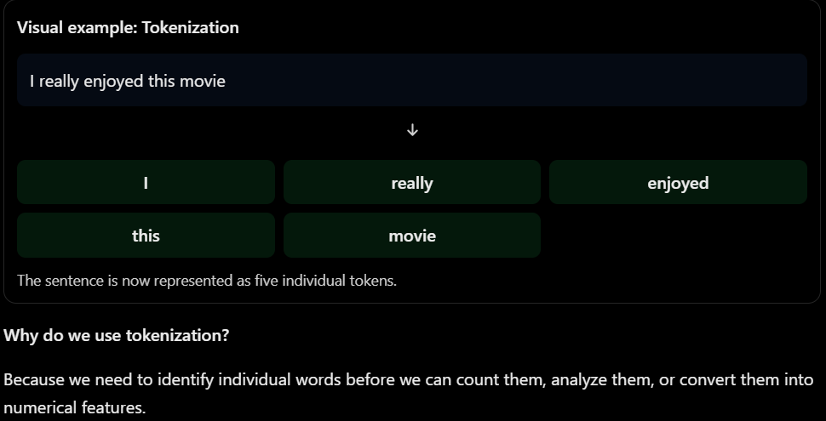

Important: Different types of tokenization
Type | Example
Word-level | ["playing", "football"]
Character-level | ["p", "l", "a", "y", "i", "n", "g"]
Subword-level | "unbelievable" → smaller word pieces
Subword tokenization is particularly important in modern NLP models such as BERT and GPT.
1.2 Stopwords
Stopwords are common words that appear frequently in a language but may contribute relatively little useful information to certain NLP tasks.
Examples in English: the, is, am, are, a, an, of, to, and
Ex :The movie is really amazing and enjoyable.
If we remove some stopwords: movie really amazing enjoyable
We have reduced the number of words while keeping much of the important information for this particular example.
Why do we remove stopwords?
In some traditional machine learning pipelines, removing stopwords can:
Reduce the number of features.
Reduce the size of the vocabulary.
Remove words that may contribute little to classification.
Make sparse text representations smaller.
But there is an important problem!
Removing stopwords is NOT always beneficial.
Consider:
I do not like this movie.
If we remove the word not: I like this movie.
We completely change the meaning!
The original sentence is negative, but the processed sentence looks positive.
Never assume that removing all stopwords improves NLP performance.
1.3 Stemming vs. Lemmatization
A. Stemming
Stemming removes prefixes or suffixes using relatively simple rules to produce a word stem.
Example:
Original word | Stem
Playing | Play
Played | Play
Plays | Play
Studies | Studi
Running | Run
Why?
Because stemming doesn't always understand the actual meaning or grammatical structure of the word. It mainly applies rules to remove word endings.

B. Lemmatization
Lemmatization converts words into their proper dictionary base form called a lemma.
Example:
Original word | Lemma
Playing | Play
Played | Play
Studies | Study
Better | Good
Running | Run
1.4 Bag-of-Words (BoW)
machine learning model still cannot directly use words as input.
We need to convert text into numbers.
Bag-of-Words is one of the simplest ways to do this.
The idea is:
1.Build a vocabulary containing unique words from our documents.
2.Count how many times each word appears in each document.
3.Represent every document as a numerical vector.
Three example documents.
Document 1:I love football Document 2: I love basketball Document 3: I hate football
Step 1: Build the vocabulary
Collect all unique words: ["I", "love", "football", "basketball", "hate"].
These words become our features.
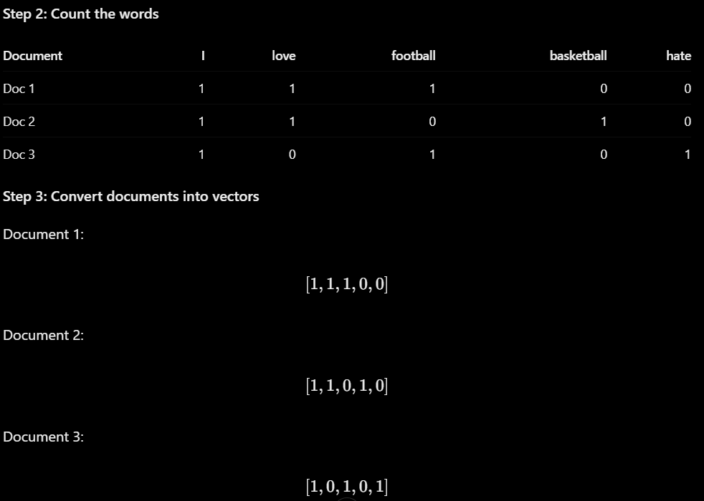
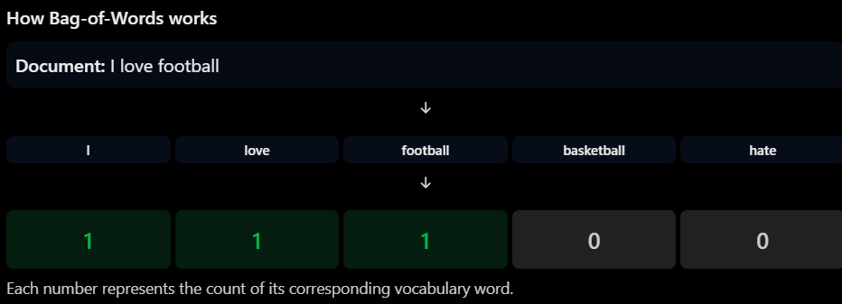

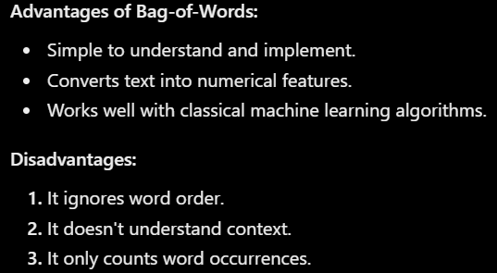
1.5 TF-IDF
TF-IDF stands for:(Term Frequency – Inverse Document Frequency)
It is another technique for converting text into numerical feature vectors.
TF-IDF considers how important a word is within a document compared with the entire collection of documents.
Ex Imagine we have 1,000 movie reviews.
The word: movie
might appear in 900 reviews.
Does this word help us distinguish positive reviews from negative reviews?
Probably not very much.
Now imagine the word:excellent
appears in only 100 reviews.
It might be more useful for identifying positive reviews.
TF-IDF tries to give more importance to words that are frequent in a particular document but relatively uncommon across the entire collection.
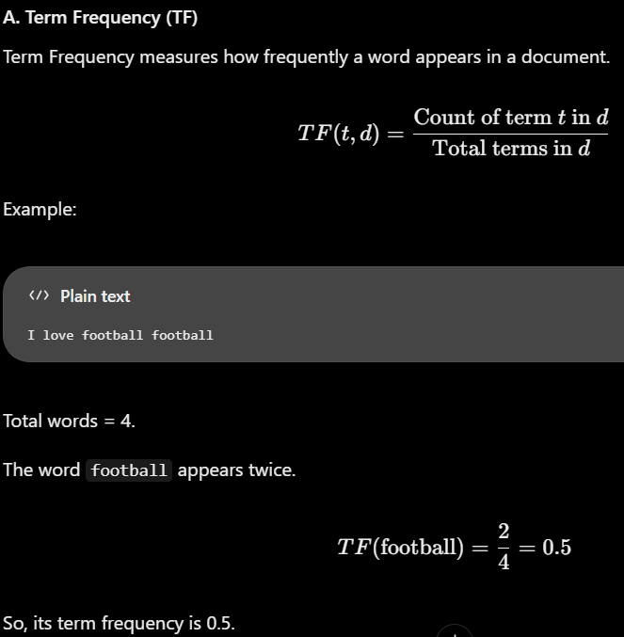
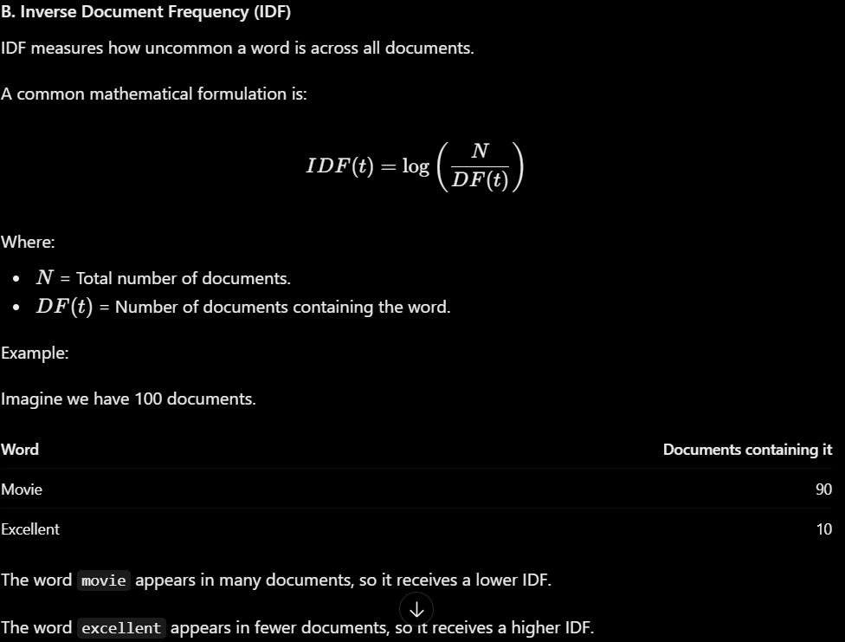

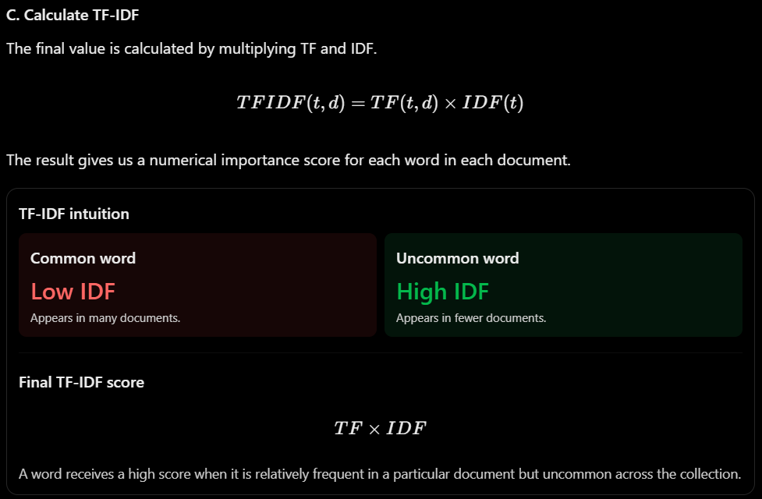
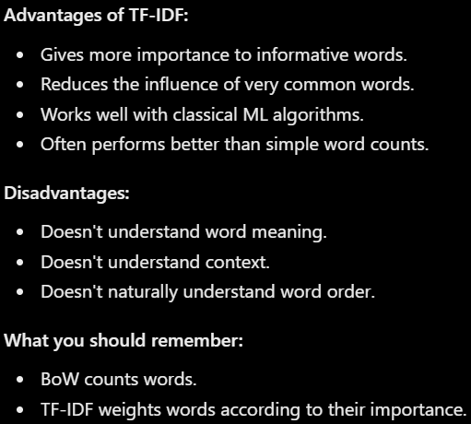
1.6 N-grams
N-grams are consecutive sequences of N tokens.
Ex I love watching football
There are three common configurations.
Unigrams (1-gram): Individual words.
I love watching football
Bigrams (2-gram): Consecutive pairs of words.
I love
love watching
watching football
Trigrams (3-gram): Consecutive groups of three words.
I love watching
love watching football
Why are N-grams useful?
Remember that Bag-of-Words and TF-IDF using only individual words ignore word order.
Consider:
The movie was not good.
If we only consider individual words, we have:
The, movie, was, not, good
But using bigrams, we can capture:
not good
This combination can provide useful information for sentiment classification.
What is the difference between:
Setting | Meaning
(1,1) | Unigrams only
(2,2) | Bigrams only
(1,2) | Unigrams and bigrams
(1,3) | Unigrams, bigrams and trigrams

- Word embeddings: dense vectors with meaning
2.1 One-Hot Encoding(Identity)
One-hot encoding is a technique that represents each word as a vector containing only zeros and one single value of 1.
Each word receives its own unique position in the vocabulary.
Let's imagine we have the following vocabulary:
["Cat", "Dog", "King", "Queen"]
Our vocabulary contains 4 words.
We assign each word a unique position:
Word | Position
Cat | 0
Dog | 1
King | 2
Queen | 3
Now we represent every word using a vector of length 4.
Cat = [1, 0, 0, 0]
Dog = [0, 1, 0, 0]
King = [0, 0, 1, 0]
Queen = [0, 0, 0, 1]
Every word has exactly one active position, and all other positions are zero.
Why is it called One-Hot?
One = Only one position Hot = That position has a value of 1.
What are the characteristics of One-Hot Encoding?
Every word has a unique vector.
Vector size equals vocabulary size.
Each vector contains one 1 and all remaining values are 0.
Every word is treated as an independent category.
The main problem with One-Hot Encoding, Let's compare:
Cat
Dog
King
Queen
We know that Cat and Dog are semantically related because they are both animals.
Similarly, King and Queen are related because they are both royal titles.
However, one-hot encoding doesn't understand these relationships.
2.2 Sparse Vectors vs. Dense Vectors
A. Sparse vectors(One-hot)
A sparse vector is a vector containing mostly zeros.
Example:
[0,0,0,0,1,0,0,0,0,0]
This vector contains 10 elements, but only one element is non-zero.
One-hot encoding is a sparse representation.
Bag-of-Words and TF-IDF also commonly produce sparse vectors because most words don't appear in most documents.

B. Dense vectors(Embedings)
A dense vector contains many non-zero numerical values.
Example:
[0.25,-0.61,0.83,0.42,-0.17]
Unlike a one-hot vector, the values are distributed across multiple dimensions.
These values are learned from data.
They can encode useful patterns about how words are used in language.
Why are dense vectors useful?
They provide a way to represent relationships between words.
For example, if a model learns from a large amount of text, words that frequently appear in similar contexts may develop similar vector representations.
This is the foundation of word embedding.
2.3 Word Embedding(Relationships)
Word embeddings are numerical representations of words in the form of dense, low-dimensional vectors.
The main idea is:
Instead of assigning every word an unrelated category, we learn numerical representations that capture patterns of meaning and usage.
Let's use these words:
King
Queen
Man
Woman
Apple
Banana
A word embedding model learns a vector for each word.
the following vectors:
Word | Embedding vector
King | [0.8, 0.7, 0.2]
Queen | [0.8, 0.6, 0.3]
Man | [0.7, 0.2, 0.1]
Woman | [0.7, 0.1, 0.2]
Apple | [-0.5, 0.8, 0.9]
Banana | [-0.4, 0.7, 0.8]
King and Queen have relatively similar representations.
Man and Woman have relatively similar representations.
Apple and Banana have relatively similar representations.
The model learns these patterns from the data it sees.
How does an embedding model learn meaning?
It uses a very important idea in NLP called the Distributional Hypothesis.

The idea is:
Words that appear in similar contexts tend to have similar meanings or uses.
Consider these sentences:
I drink coffee every morning.
I drink tea every morning.
I love playing football.
I love playing basketball.
Notice that:
Coffee and tea appear in similar contexts.
Football and basketball appear in similar contexts.
A word embedding model learns from these patterns.
Over time, words used in similar contexts can develop similar vector representations.
Important: The model does not understand language exactly like a human. It learns statistical patterns from text.
How are embeddings different from TF-IDF?
Feature | TF-IDF | Word Embeddings
Representation | Sparse | Dense
Dimensions | Usually vocabulary-sized | Usually fixed-size
Values | Importance scores | Learned numerical values
Semantic similarity | Not inherently captured | Can be captured
Word context | Limited | Learned from context patterns
Example | Word importance in a document | Word representation
How many dimensions do embeddings have?
An embedding can have a fixed number of dimensions, such as:
50 dimensions.
100 dimensions.
200 dimensions.
300 dimensions.
For example, a 300-dimensional embedding represents each word using 300 numerical values.
This is much smaller than a one-hot representation when the vocabulary contains thousands of words.
However, the number of dimensions is a design choice, not a universal rule.
2.4 Word2Vec
is a technique that learns dense word representations by training a neural network on the surrounding context of words.
Its central idea is to learn word representations by predicting relationships between words and their contexts.
There are two main Word2Vec architectures:
CBOW (Continuous Bag of Words).
Skip-gram.

A. CBOW – Continuous Bag of Words
CBOW tries to predict the missing or target word using its surrounding context words.
Example sentence:
The cat is drinking milk
Imagine that our target word is:
drinking
The surrounding context words are:
cat, is, milk
CBOW uses these surrounding words to predict the target word.
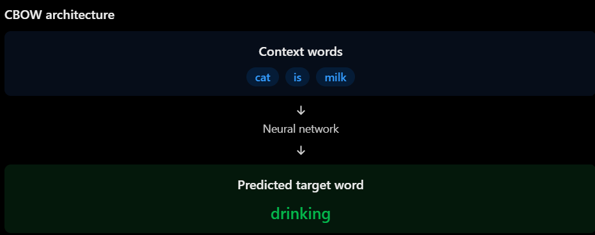
What does CBOW learn?
It learns to recognize which words are likely to appear based on their surrounding context.
B. Skip-gram
Skip-gram works in the opposite direction.
Instead of using surrounding words to predict the target word, it uses the target word to predict surrounding context words.
Using the same sentence:
The cat is drinking milk
Our target word is:
drinking
Skip-gram tries to predict surrounding words, such as:
cat, is, milk
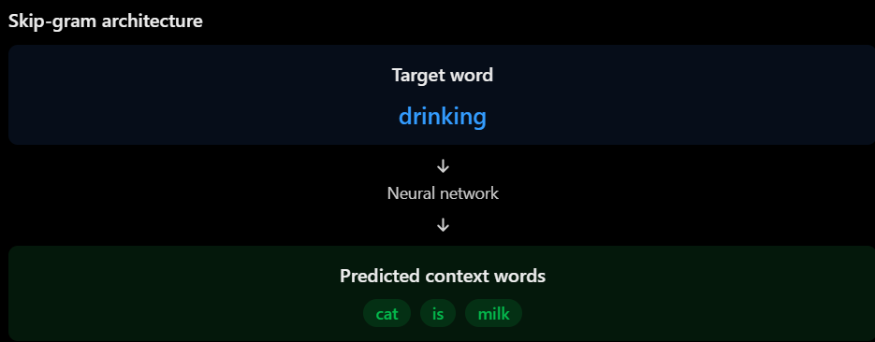
CBOW: Context predicts the word.
Skip-gram: Word predicts the context.
Both approaches learn embeddings during training.
What happens during training?
At a high level:
- The model receives training text.
- It creates training examples from words and their contexts.
- The neural network makes predictions.
- It calculates prediction errors.
- It updates its weights using backpropagation and optimization.
- The learned weights provide the word vectors.
The important part is that the embedding vectors are learned through training, rather than manually assigned.
2.5 GloVe (Global Vectors for Word Representation)
GloVe learns word vectors using global statistical information about how frequently words appear together across an entire text corpus.
Let's understand the difference between local and global information.
Imagine a large collection of documents containing these words:
Football
Player
Goal
Stadium
Banana
Apple
GloVe builds and uses word co-occurrence statistics.
For example:
Football frequently appears near player.
Football frequently appears near goal.
Apple frequently appears near banana.
These co-occurrence patterns help GloVe learn word representations.
What is a co-occurrence matrix?
A co-occurrence matrix records how often words appear near other words within a defined context window.
Imagine this simplified matrix:
 | Football | Player | Goal | Apple
Football | 0 | 15 | 20 | 0
Player | 15 | 0 | 12 | 0
Goal | 20 | 12 | 0 | 0
Apple | 0 | 0 | 0 | 0
The matrix helps capture relationships between words based on their co-occurrence statistics.
GloVe uses these global statistics to learn vectors.
Word2Vec vs. GloVe
Feature | Word2Vec | GloVe
Main approach | Predictive | Count-based / statistical
Learning information | Local context windows | Global co-occurrence statistics
Architectures | CBOW and Skip-gram | Matrix-based objective
Output | Dense word vectors | Dense word vectors
Goal | Learn useful word relationships | Learn useful word relationships
Important: Both methods produce dense word embeddings.
Neither method guarantees that every semantic relationship will be captured correctly.
Word2Vec: Learns by predicting words and their contexts.
GloVe: Learns from global word co-occurrence statistics.

2.6 Semantic Relationships and Vector Arithmetic
Remember: every word has a vector.
These vectors are points in a mathematical space.
When trained appropriately, some relationships between words can be represented through directions and differences between vectors.
A. Semantic similarity
Words with similar meanings or usage can have vectors that are relatively close to each other.
Examples:
King and Queen.
Cat and Dog.
Football and Basketball.
Apple and Banana.
We can measure this similarity using cosine similarity. Fourmula:
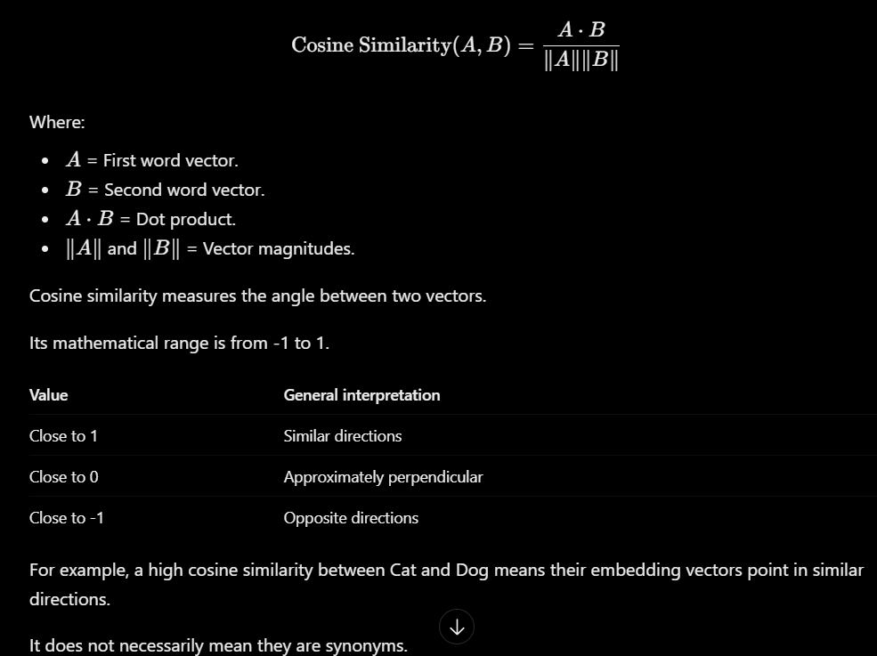
B. Vector arithmetic
Word embeddings can sometimes capture relationships using vector offsets.
A famous illustrative example is:
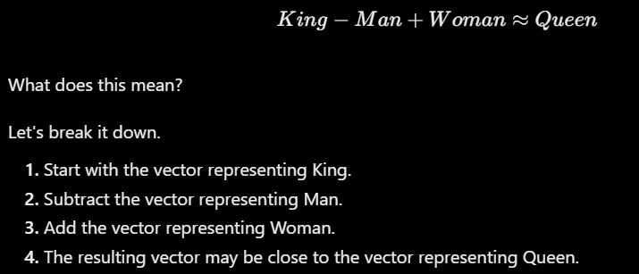
Paris − France + Italy ≈ Rome.
Walking − Walk + Swim ≈ Swimming.
These relationships are not guaranteed.Important limitation:
Vector arithmetic is an approximate pattern learned from the training data. Results depend on the embedding model, vocabulary, training corpus, and representation.
It does not mean the model has human-like understanding of gender, geography, or grammar. Embeddings can also reflect biases present in their training data.
2.7 Nearest Neighbors in Word Embeddings
What are Nearest Neighbors?
Nearest neighbors are the words whose embedding vectors are closest to a selected word according to a distance or similarity measure.
For example, imagine we search for the nearest neighbors of:
Football
A pretrained embedding might return words such as:
Soccer
Basketball
Player
Goal
Stadium
These are examples of plausible neighbors, not guaranteed results from a particular model.
How does it work?
Select a word, such as Football.
Retrieve its embedding vector.
Compare it with the vectors of other words.
Calculate cosine similarity.
Sort the words by similarity.
Return the closest words.
Example:
Word | Illustrative cosine similarity
Soccer | 0.91
Basketball | 0.82
Player | 0.79
Stadium | 0.73
Banana | 0.12
Why is this useful?
Nearest neighbors help us investigate what relationships the embedding model has learned.
For example, we can check whether:
Sports-related words appear near other sports-related words.
Countries appear near geographically or contextually related countries.
Similar grammatical forms appear near each other.
However, nearest neighbors depend on the training corpus. A word may be close to another because they frequently appear together, even if they are not synonyms.

2.8 Visualizing Word Embeddings: PCA and t-SNE
Now imagine we have a pretrained Word2Vec model containing 300-dimensional vectors.
How can we visualize 300 dimensions?
A normal graph only allows us to display:
2 dimensions (X and Y).
3 dimensions (X, Y and Z).
We cannot directly plot 300 dimensions on a normal 2D graph.
This is where dimensionality reduction comes in.
Dimensionality Reduction means reducing the number of dimensions while attempting to preserve some important structure in the data.
Two popular methods are PCA and t-SNE.
A. PCA – Principal Component Analysis
PCA is a dimensionality reduction technique that transforms data into new axes called principal components.
Its objective is to preserve as much of the original data's variance as possible in the selected number of dimensions.
Imagine that we have word vectors with 300 dimensions.
PCA identifies directions that capture the greatest variance in the data and projects the vectors onto the first two principal components.
We can then plot the resulting coordinates.
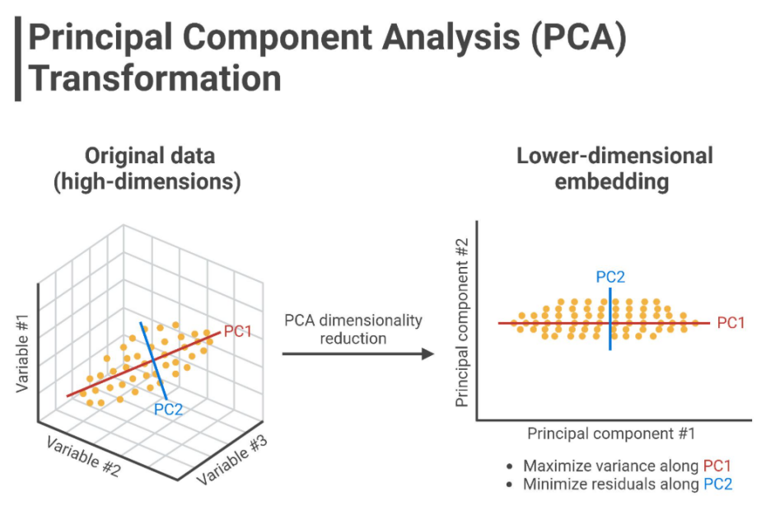
How does PCA work conceptually?
Start with high-dimensional vectors.
Analyze the variance and relationships across dimensions.
Identify principal components.
Select the first two components.
Project the original vectors onto these components.
Plot the resulting 2D points.
What does PCA preserve?
It tries to preserve the maximum possible overall variance in the selected dimensions.
Advantages:
Relatively fast, Useful for exploring broad structure, Deterministic for a fixed dataset and configuration, subject to implementation details.
Can be useful for visualizing groups of related words.
Limitation:
Reducing 300 dimensions to 2 necessarily loses information.
Two words that are close in the original embedding space might not look equally close in the 2D projection.
B. t-SNE – t-distributed Stochastic Neighbor Embedding
t-SNE is another dimensionality reduction technique, especially useful for visualizing local neighborhood structures.
Unlike PCA, which focuses on preserving overall variance, t-SNE tries to preserve similarities between nearby data points.
Imagine these word groups:
King, Queen, Prince, Princess.
Cat, Dog, Horse, Lion.
Apple, Banana, Orange, Mango.
A t-SNE visualization may display these words as separate local groups if their original embeddings have similar neighborhood structures.
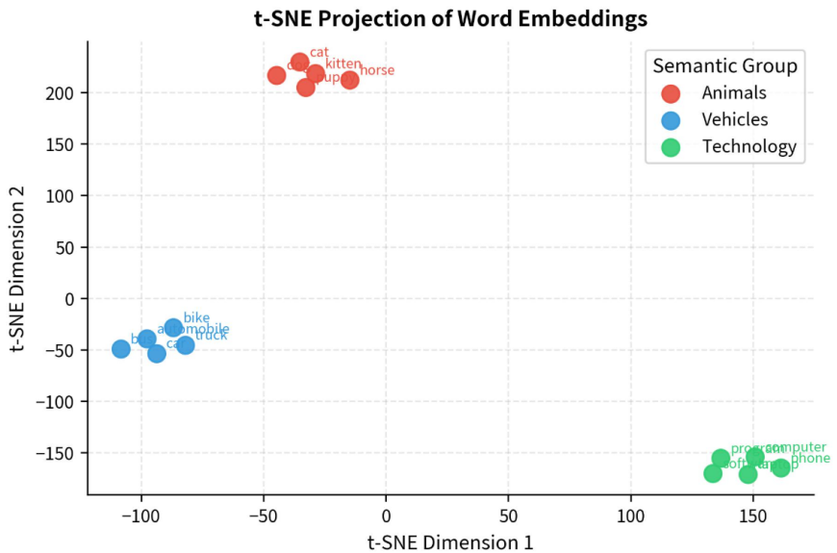
How does t-SNE work conceptually?
Start with high-dimensional word vectors.
Calculate similarities between points in the original space.
Create a lower-dimensional representation.
Adjust the positions of points to preserve local neighborhood relationships as much as possible.
Produce a 2D visualization.
Advantages:
Useful for visualizing local clusters.
Can reveal neighborhood structures that are difficult to inspect in high-dimensional data.
Limitations:
Can be computationally expensive.
Results can change with initialization and parameters.
Distances between separate clusters are not necessarily meaningful.
It can make apparent clusters look more distinct than the original structure justifies.
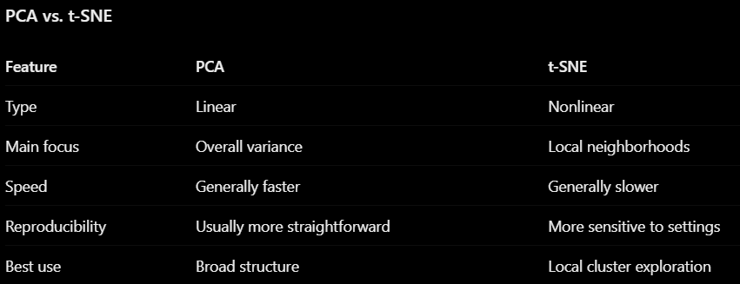
How should we interpret the plots?
Suppose we plot these words:
King, Queen, Prince, Princess,
Cat, Dog, Horse, Lion,
Apple, Banana, Orange, Mango
And we observe that some words appear close together.
Can we conclude that the model understands their meanings? No.
We can only say that the visualization suggests some relationships in the embedding representation.
Why?
BecauseThe original vectors may contain hundreds of dimensions.
We compressed them into only two dimensions.
The visualization may distort distances.
The result depends on the dimensionality reduction method and its settings.
The correct interpretation is:
The visualization suggests that words with related usage patterns occupy nearby regions in this particular embedding representation. However, a 2D projection does not prove semantic relationships.
- Recurrent neural networks and sequence order
What is an RNN?
RNN stands for Recurrent Neural Network.
An RNN is a type of neural network designed to process sequential data.
Examples of sequential data include:
Text and sentences.
Speech and audio.
Time-series data.
Stock prices over time.
Weather measurements.
Video frames.
Why do we need a special architecture for sequences?
Because in sequential data, the order of the information matters.
Let's take two sentences:
Sentence 1: I love this movie.
Sentence 2: I hate this movie.
The words love and hate completely change the meaning.
A model that treats every word as an independent feature may struggle to understand the relationship between words and their order.
An RNN is designed to process the sequence one element at a time while carrying information from previous elements.
The main idea
Imagine reading this sentence:
I love watching football
A human reads it from left to right:
Reads I.
Reads love.
Reads watching.
Reads football.
When reading football, you still remember the previous words.
An RNN follows a similar processing idea.
It processes one token at a time and maintains a representation of previous information called the hidden state.
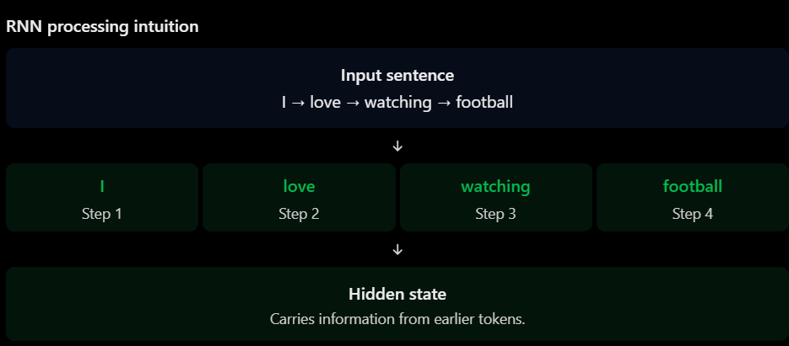
Important: An RNN doesn't process the entire sentence independently at once. It processes the sequence step by step.
Why do we need RNNs?
A. Traditional Feedforward Neural Network
A feedforward neural network receives input and passes it through layers to produce an output.
It doesn't naturally maintain a memory of previous inputs.
For example:
Input → Hidden Layer → Output
If we give it individual words without additional sequence information, it doesn't inherently know which word came first.
B. Recurrent Neural Network
An RNN has an additional mechanism: it passes information from one time step to the next.
Input → RNN → Output
↑
Previous state
This allows the network to use information from previous tokens when processing the current token.
Comparison
Feature | Feedforward NN | RNN
Processes sequences | Not inherently | Yes
Maintains hidden state | No recurrent state | Yes
Uses previous inputs | Not inherently | Through hidden state
Understands order | Requires additional design | Naturally processes ordered inputs
Typical application | Image classification | Text, speech, time series
The main advantage of an RNN is its ability to maintain information across sequential steps.
How does an RNN work?
To understand an RNN, we need to understand three things:
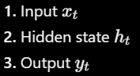
Let's understand each one.
3.1 Input (x)
For NLP, this is usually the numerical representation of the current token.
For example: I love watching football
The RNN receives:
Time step | Input
t=1 | I
t=2 | love
t=3 | watching
t=4 | football
In a real neural network, these tokens are represented numerically, often using word embeddings.
3.2 Hidden State (h)
A hidden state is a vector that carries information from previous time steps.
You can think of it as the RNN's running memory.
For example: Imagine we are processing:
I love watching football
At each step, the RNN updates its hidden state.
Time step | Current input | What the hidden state can represent
1 | I | Information about "I"
2 | love | Information about "I love"
3 | watching | Information about "I love watching"
4 | football | Information about the complete sequence
Important: The hidden state is updated at every time step. It combines information from the current input and the previous hidden state.

3.3 Output (y)
The output is the prediction produced by the network.
Depending on the task, the RNN can produce:
A sentiment classification.
A predicted next word.
A prediction at every time step
We will distinguish these tasks later.
3.4 The RNN mathematical equation
Now let's understand how the RNN updates its hidden state.
The main equation is:
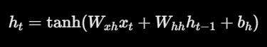
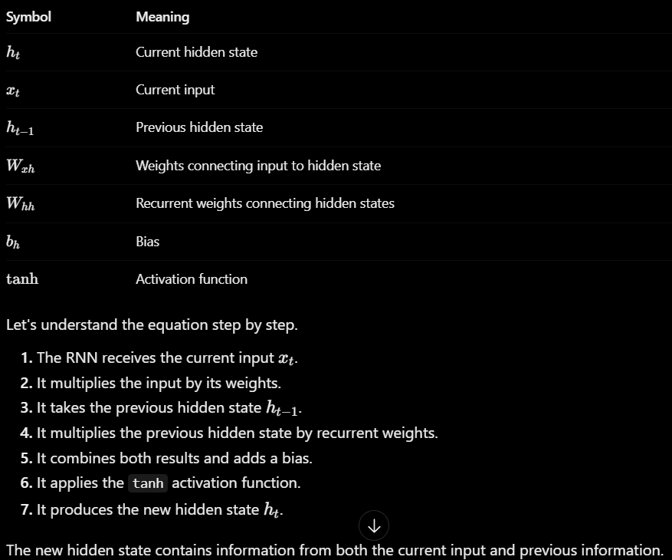
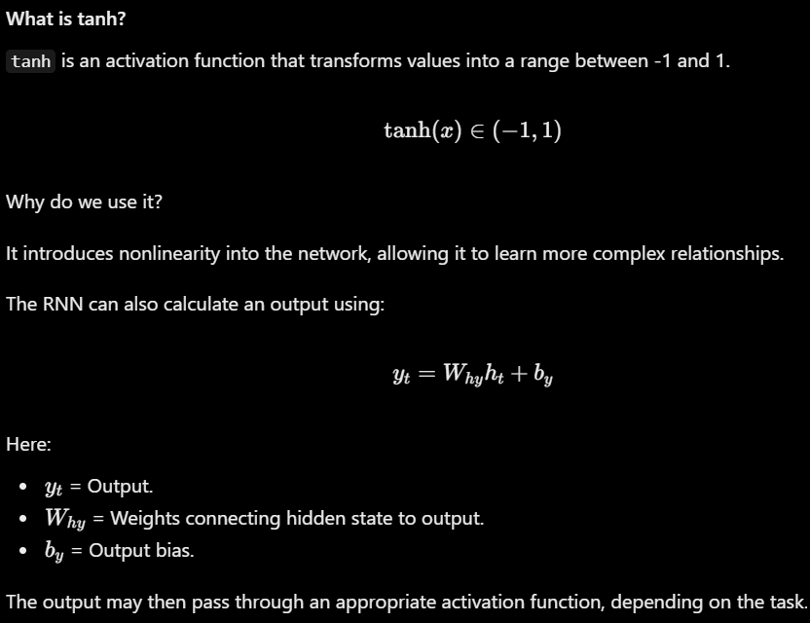
RNN Architecture: How information flows through time
Ex I love watching football
We will process it through four time steps.
1 Unrolled RNN
An RNN is recurrent, meaning the same network is used repeatedly for each time step.
When we draw it across time, we call this an unrolled RNN.
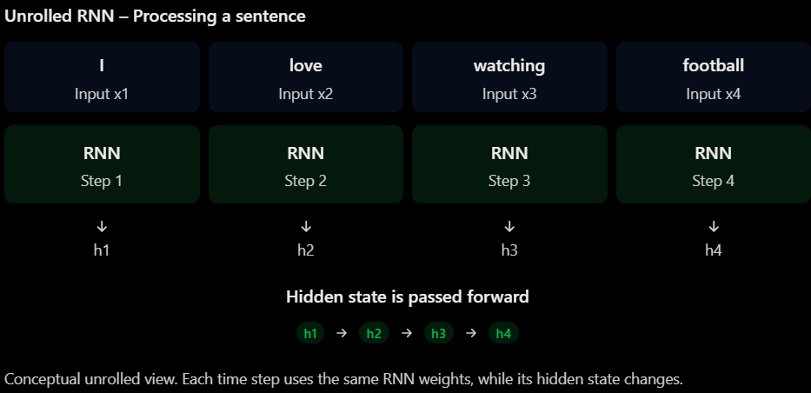
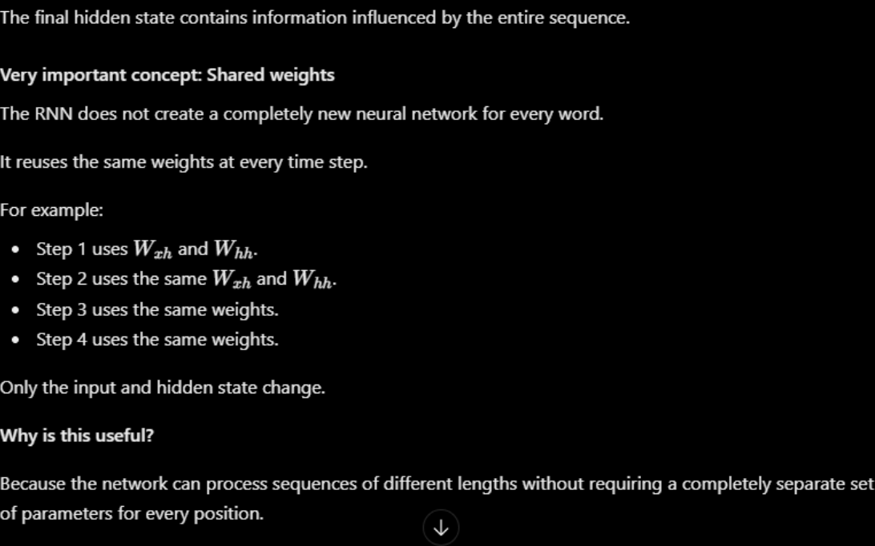
Why does sequence order matter?
Let's compare two sentences:
Sentence A: The dog chased the cat. Sentence B: The cat chased the dog.
Both sentences contain exactly the same words.
However, their meanings are different.
In Sentence A:
Dog = The one chasing.
Cat = The one being chased.
In Sentence B:
Cat = The one chasing.
Dog = The one being chased.
A model that only considers word frequency might struggle to distinguish these sentences.
An RNN processes tokens in their original order.
Therefore, the hidden state is updated differently depending on the order of the inputs.
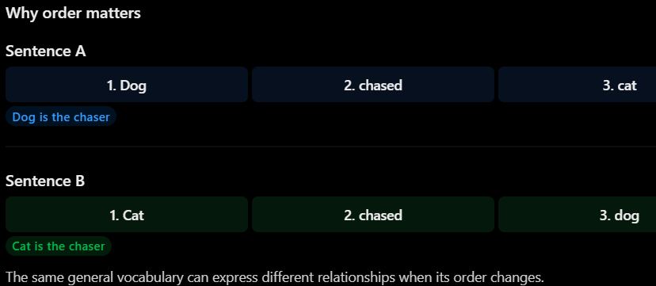
An RNN processes words sequentially, and the hidden state depends on the order in which the inputs are received.
Sequence Classification vs. Sequence Generation
An RNN can be used for different NLP tasks.
Sequence Classification
means that the model receives an entire sequence and produces a class label.
For example, sentiment analysis.
Input:
I absolutely love this movie.
Output:
Positive
Another example:
The movie was boring and terrible.
Output:
Negative
The RNN processes the entire review and uses the information it has accumulated to predict one label.
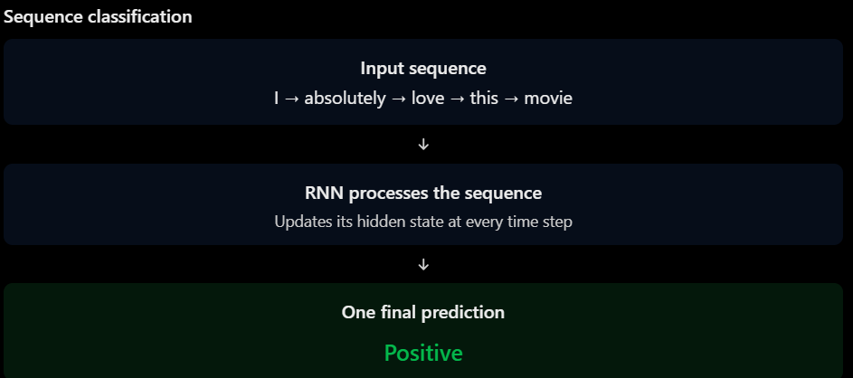

Sequence Generation
means the model generates a sequence of outputs, often predicting the next token repeatedly.
For example, imagine we give the model:
I love
It predicts:
football
Then we use the generated sequence:
I love football
The model predicts the next token:
because
Then:
I love football because
It continues generating tokens until it reaches a stopping condition.
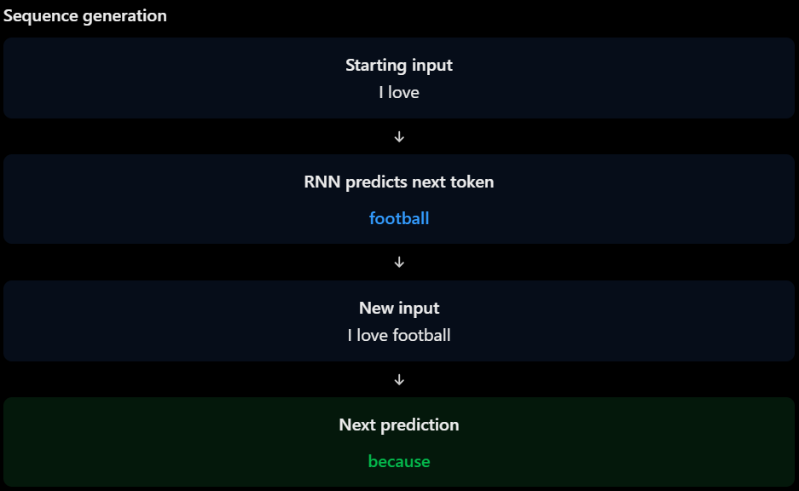
Many-to-One vs. Many-to-Many Architectures
Many-to-One
Many-to-One means:
The model receives multiple inputs.
The model produces one output.
This is the architecture commonly used for sentiment classification.
Example:I love this amazing movie
The model receives five tokens but produces only one prediction:
Positive
Many-to-Many
Many-to-Many means:
The model receives a sequence of multiple inputs.
The model produces multiple outputs across sequence positions.
For example, imagine we want to classify every word in a sentence according to its grammatical role or entity type.
Input:
John lives in Cairo
Output:
John → PERSON
lives → OTHER
in → OTHER
Cairo → LOCATION
The model produces an output for each token.
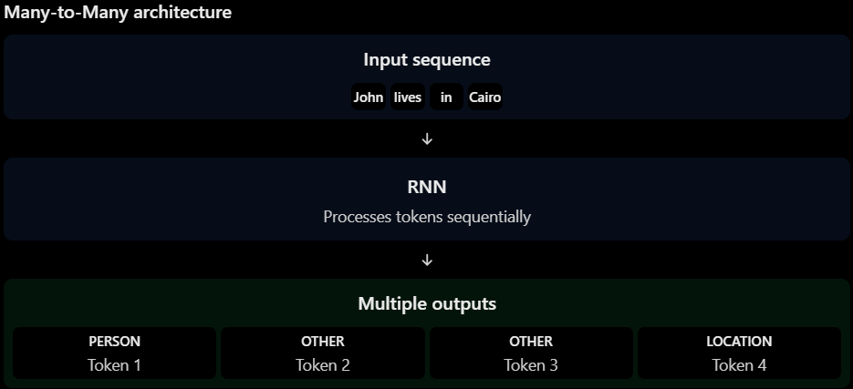
Another type of Many-to-Many: Sequence-to-Sequence
Sometimes the model receives one sequence and produces another sequence, but the input and output lengths don't have to be the same.
Example: Machine translation.
Input: I love football
Output: أنا أحب كرة القدم
The model processes an input sequence and generates an output sequence.
This is often called a Sequence-to-Sequence (Seq2Seq) architecture.
It is also a many-to-many setup, but unlike token-level labeling, the output sequence can have a different length and structure from the input.
Comparison
Architecture | Input | Output | Example
Many-to-One | Multiple tokens | One label | Sentiment analysis
Many-to-Many | Multiple tokens | Multiple outputs | NER
Seq2Seq | One sequence | Another sequence | Translation
Problems with Vanilla RNNs
Although RNNs can process sequences and maintain hidden states, vanilla RNNs have a significant limitation.
They can struggle to learn long-range dependencies.
To understand this, let's first understand what a long-range dependency means.
What are Long-Range Dependencies?
occurs when information from an earlier part of a sequence is important for understanding or predicting something much later in that sequence.
Example:
The movie, despite its slow beginning,
boring dialogue, and weak first half,
was absolutely fantastic.
Imagine the model is trying to predict the sentiment.
The final word fantastic is positive, but understanding the entire review requires considering information from different parts of the sentence.
Another example:
The movie was not, despite what the
advertisements suggested, particularly good.
The word not appears much earlier than good.
The relationship between these words is important.
An RNN attempts to carry information from earlier time steps through its hidden state.
However, as the sequence becomes longer, it can become difficult to preserve useful information.
This leads us to two problems:
Vanishing gradients.
Exploding gradients.
Feature | Vanishing Gradients | Exploding Gradients
Gradient magnitude | Becomes very small | Becomes very large
Main problem | Weak learning signals | Unstable updates
Learning behavior | Difficult to learn long dependencies | Training may become unstable
Possible solution | LSTM / GRU architectures | Gradient clipping
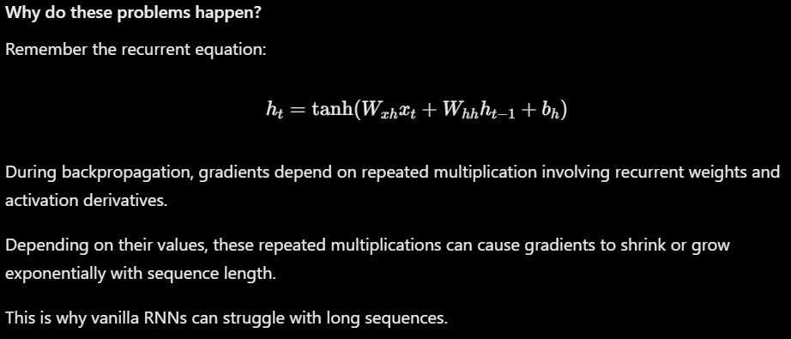
Why is this important before learning LSTM?
One important improvement is the Long Short-Term Memory (LSTM) network.
LSTM was designed to help RNNs preserve and manage information over longer periods.
It introduces a memory cell and gates that control information flow.
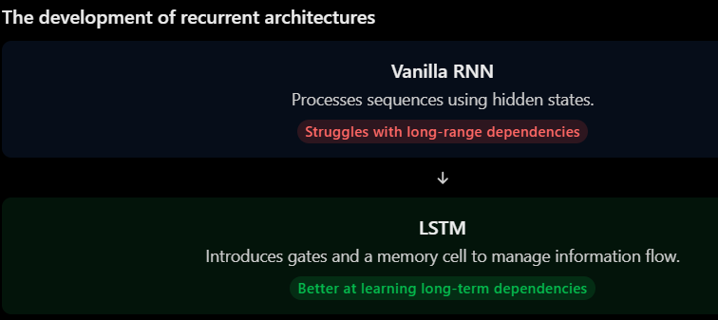
One important qualification: LSTM helps mitigate the vanishing-gradient problem, but it does not guarantee that gradients can never vanish or explode.
- LSTM/GRU gates and the baseline-versus-LSTM comparison
Why do we need LSTM and GRU?
LSTM and GRU were designed to improve how recurrent networks preserve and update information over time.
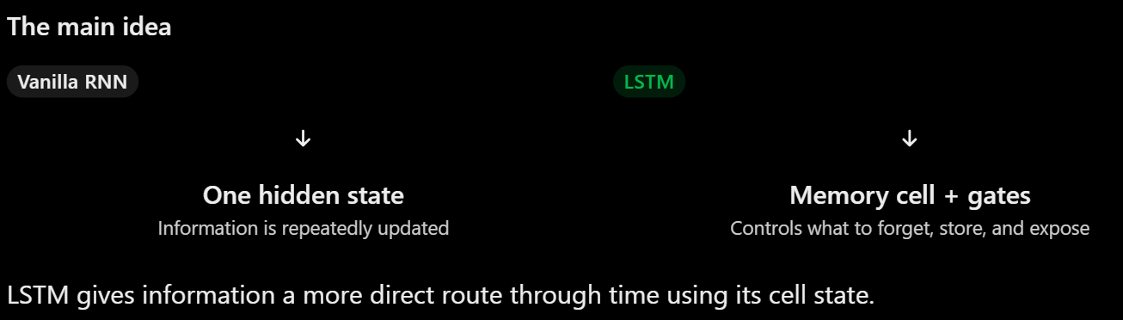
What is an LSTM?
LSTM stands for Long Short-Term Memory.
It is a special type of RNN designed to remember useful information for longer periods.
The important difference is that an LSTM maintains two states:
State | Meaning
Hidden state (ht) | Information exposed to the next layer or used for output
Cell state (Ct) | The internal memory that carries information across time
Think of the cell state as a memory notebook.
Some information can be erased.
New information can be written.
Selected information can be shown as the output.
The LSTM uses three gates to control these operations.
The three LSTM gates
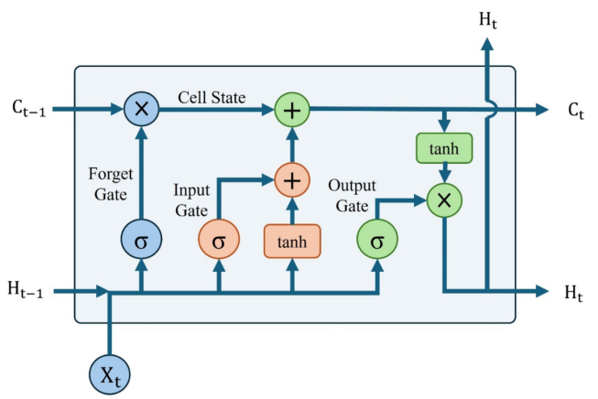
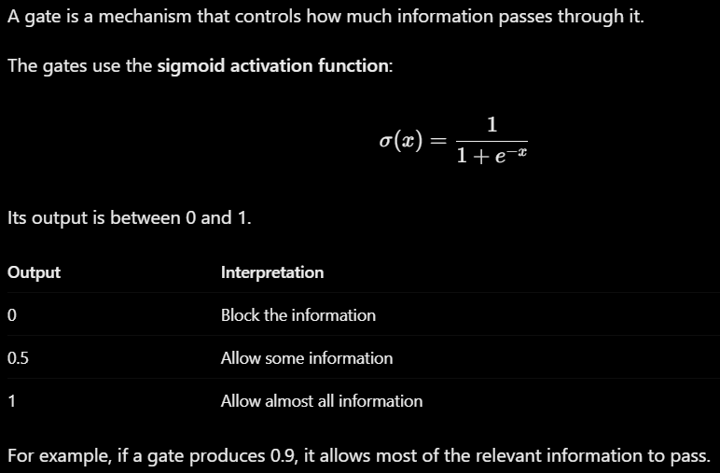
Gate 1: Forget gate
Question: What information should the LSTM forget?
The forget gate decides which parts of the previous cell state should be kept and which should be discarded.
Its equation is:
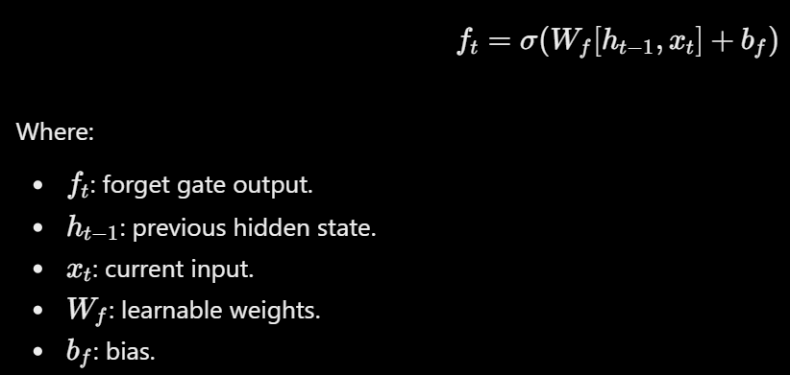
Ex Suppose the previous sentence context contains information about a movie's genre, but the current sentence starts discussing a different movie.
The LSTM may learn to reduce the importance of the old movie-related information.
If the forget gate produces:
ft=0.1
Then only 10% of the corresponding previous memory value remains.
If it produces:
ft=0.9
Then 90% remains.
Remember: The forget gate controls how much previous memory survives.
Gate 2: Input gate
Question: What new information should the LSTM remember?
The input gate decides which new information should be written into the cell state.
It has two parts.
First, the input gate decides how much information to write:
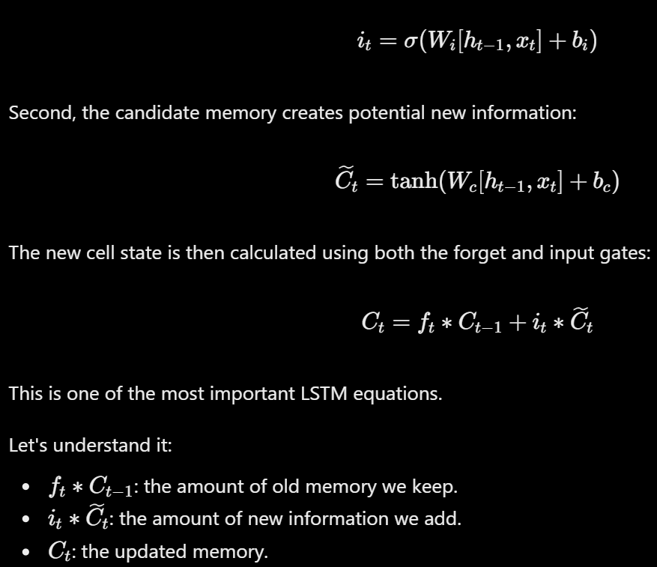
Ex The model reads: The movie was not good.
When it reaches not, it can learn to store the negation information in its cell state. When it later reads good, that information can still influence the final sentiment prediction.
Remember: The input gate controls what new information enters memory.
Gate 3: Output gate
Question: What information should the LSTM expose?
The output gate decides which parts of the cell state should contribute to the new hidden state.
Its equations are:
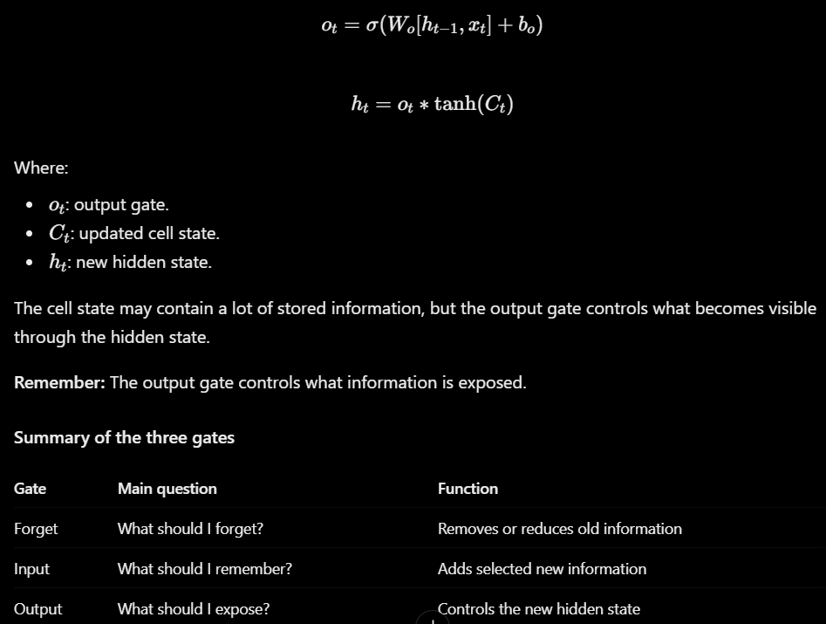
How does the LSTM update its memory?
Now let's connect the three gates into one process.
Imagine the LSTM is processing a sentence one word at a time.
At every time step, it performs these operations:
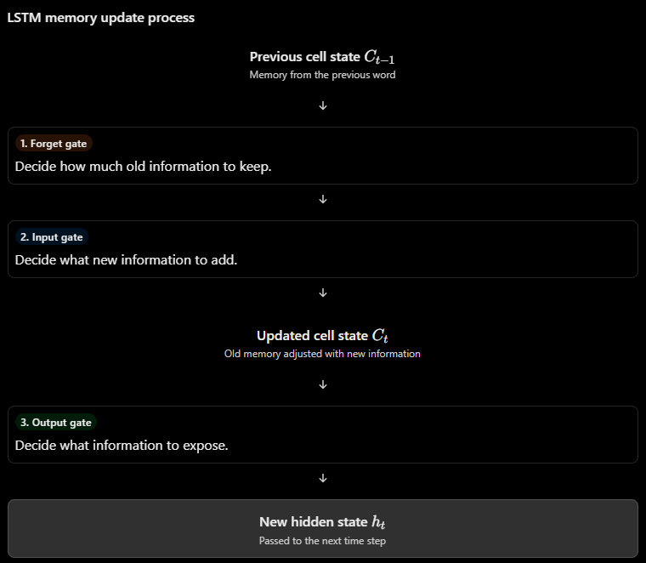

The process repeats for every word in the sequence.
Why does this help with vanishing gradients?
In a vanilla RNN, information and gradients pass through repeated hidden-state transformations. Over many time steps, gradients can become extremely small.
In an LSTM, the cell state has a more direct path through time:
Notice that the previous cell state is multiplied by the forget gate and added to new information.
When the forget gate is close to 1, the LSTM can preserve much of the previous memory. This creates a more direct route for information and gradients to travel across time.
Important: LSTMs help mitigate vanishing gradients; they do not guarantee that vanishing or exploding gradients will never happen.
What is a GRU?
GRU stands for Gated Recurrent Unit.
Like an LSTM, it is a type of RNN that uses gates to control information flow and help preserve useful information over time.
However, a GRU has a simpler architecture.
An LSTM has:
Three gates.
A separate cell state.
A hidden state.
A GRU has:
Two gates.
No separate cell state.
A hidden state that carries the memory.
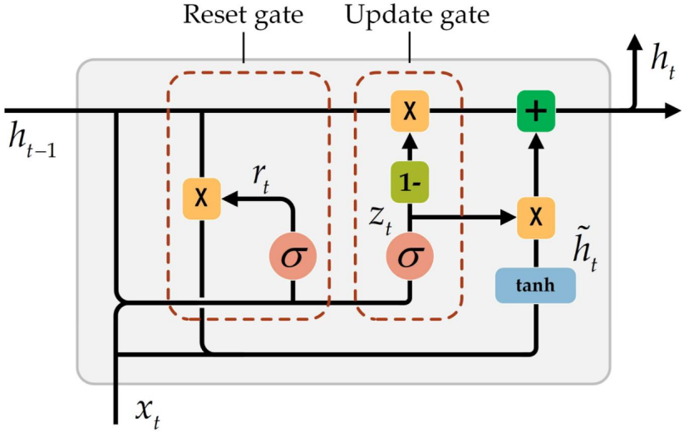
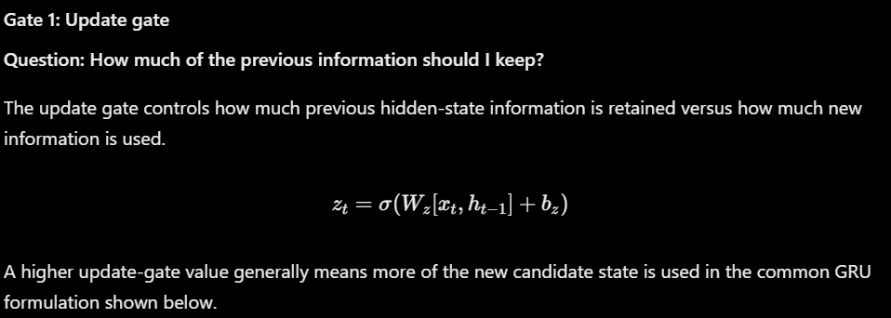
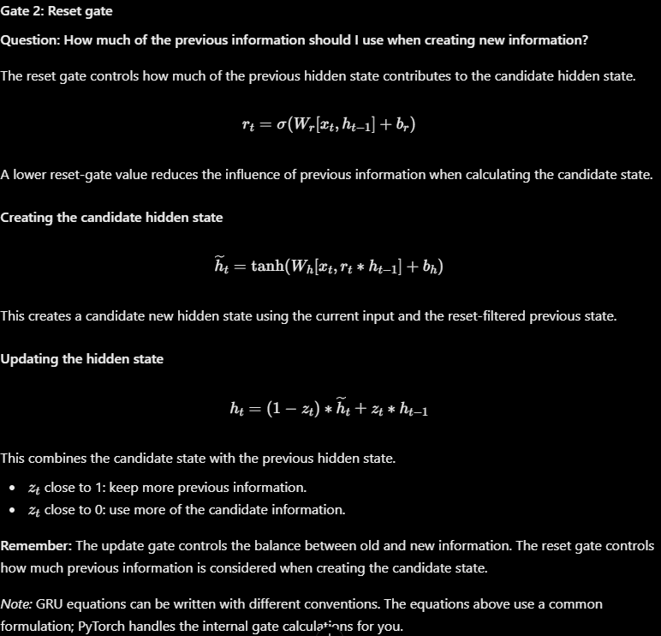

LSTM vs GRU vs vanilla RNN
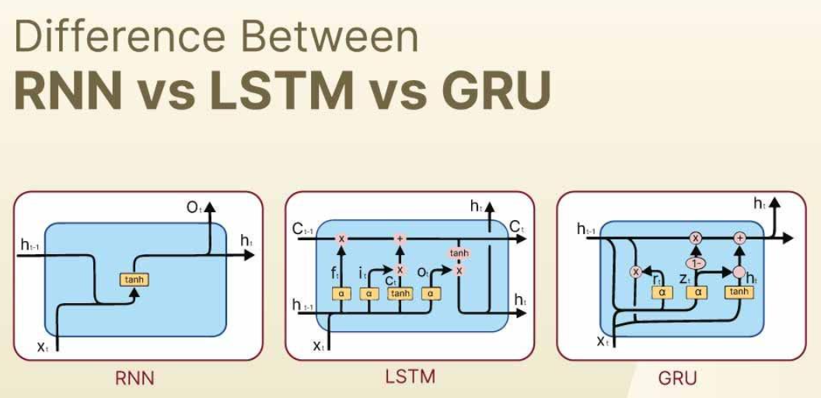
Feature | Vanilla RNN | LSTM | GRU
Gates | None | 3 | 2
Separate cell state | No | Yes | No
Hidden state | Yes | Yes | Yes
Long-term dependencies | Often struggles | Better at handling them | Better at handling them
Architecture | Simple | More complex | Simpler than LSTM
Parameters | Usually fewer | Usually more | Usually fewer than LSTM
Which one is better?
There is no universal winner.
Vanilla RNN: A simple baseline for understanding recurrent processing.
LSTM: Useful when you want explicit control over memory and need to capture longer dependencies.
GRU: A simpler gated alternative that can sometimes achieve similar performance with fewer parameters.
The best choice depends on the dataset, sequence length, model settings, and training results.
A. TF-IDF + Logistic Regression
TF-IDF It represents each document using numerical values that reflect the importance of its words.
For example:The movie was excellent and enjoyable.
The model converts the document into a sparse numerical vector.
Logistic Regression then learns which words or word combinations are associated with each class.
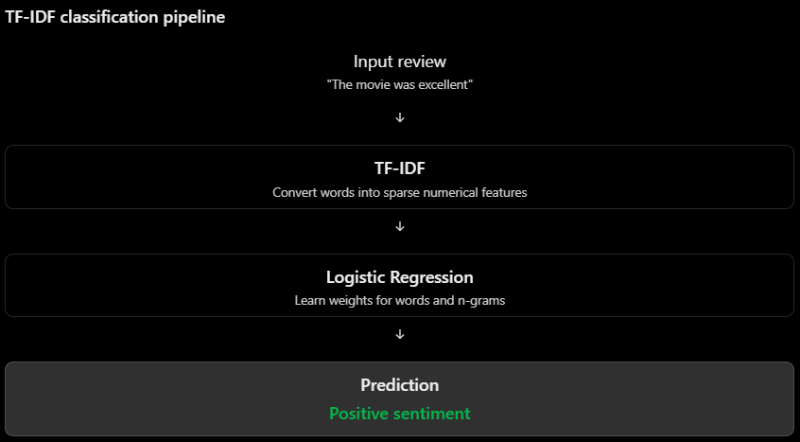
Advantages:
Fast to train.
Often performs very well on small and medium-sized datasets.
Works especially well when individual words or phrases strongly indicate the class.
Easier to tune and interpret.
Limitations:
Does not naturally understand word order across the whole sentence.
Does not learn contextual representations in the way a neural sequence model does.
Similar words are not automatically represented as similar features.
B. LSTM classifier
An LSTM processes the sequence of words in order.
For example:The movie was not good.
It receives the token sequence one word at a time. Its hidden and cell states are updated as it processes each token.
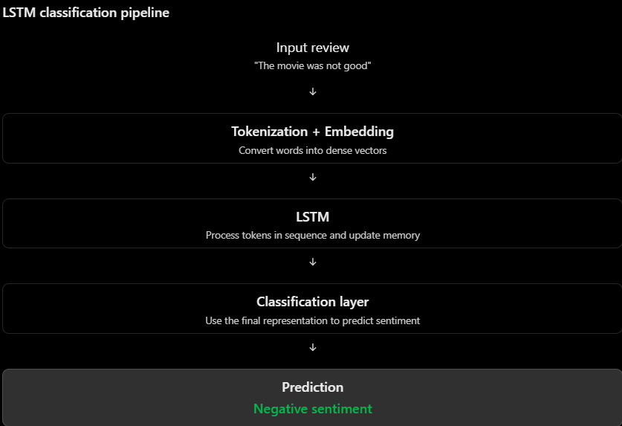
Advantages:
Processes words in their original order.
Can learn relationships between words.
Can learn to retain useful context from earlier tokens.
Learns its own task-specific representations when embeddings are trained from scratch.
Limitations:
Takes longer to train.
Has more hyperparameters to tune.
Can overfit when the dataset is small.
Needs careful choices for vocabulary size, sequence length, embeddings, and regularization.
Why can TF-IDF + Logistic Regression beat an LSTM?
You might expect LSTM to always win because it is a more advanced neural network. But a more complex model does not automatically produce better results.
Consider two situations.
Situation 1: TF-IDF wins
Imagine you have only 2,000 movie reviews.
Most positive reviews contain words such as:
Excellent, Amazing, Enjoyable, Wonderful
Most negative reviews contain:
Terrible, Boring, Awful, Disappointing
TF-IDF can identify these strong word signals very effectively.
An LSTM, on the other hand, must learn useful word representations and sequential relationships from a relatively small dataset.
It may not have enough training examples to learn those patterns reliably.
Possible outcome
TF-IDF + Logistic Regression achieves better validation or test performance.
Situation 2: LSTM wins
Imagine you have a larger dataset containing more complicated sentences:
"I thought the movie would be terrible, but it was amazing."
"The acting was not bad, although the story was disappointing."
"I expected to enjoy it, but I did not."
Here, word order and context matter more.
An LSTM has the ability to learn relationships between words and retain useful information across the sequence.
With sufficient data and suitable training, it may outperform the TF-IDF baseline.
Possible outcome
LSTM achieves better validation or test performance.
What factors influence the result?
Factor | How it affects the comparison
Dataset size | Small datasets often favor simpler models
Sequence length | Longer sequences can make recurrent learning harder
Vocabulary | Rare words can be difficult for either approach to learn reliably
Word-count signals | Strong sentiment words can favor TF-IDF
Word order and context | Can give LSTM an advantage
Hyperparameter tuning | Poor settings can make LSTM perform badly
Overfitting | LSTM may memorize training examples instead of generalizing
Training time | TF-IDF is often much faster
Important conclusion: A well-matched sparse baseline can outperform a poorly tuned deep learning model. Model complexity is not the same as model quality.

